**ECE 1895 - Space Invaders Bop It**

**Overview:**

We have chosen to design a Space Invaders themed flight simulation for our bop-it project, with three unique inputs. There is a steering wheel, a throttle, as well as a button. The steering wheel will mimic the steering of the rocket. The throttle will mimic the acceleration of the rocket, and the button will mimic shooting obstacles. The button and throttle will have unique sounds, to go with each of them, and we will issue commands through a speaker as well. The user will have four different commands, turn left, turn right, throttle up, and shoot asteroids. These will all be rewarded with points signified by a “Ding” sound, as well as an incrementing of a score counter on the design, and a green led will flash. When the player loses the game, the score will flash on the led screen, the game will make a crashing sound, and an led will flash red before the score resets to 0 and the game restarts, when you press start. Each time the player correctly completes a task, the allocated amount of time will decrease for the following tasks. The game will end when the score exceeds 99.

**Block Diagram:**

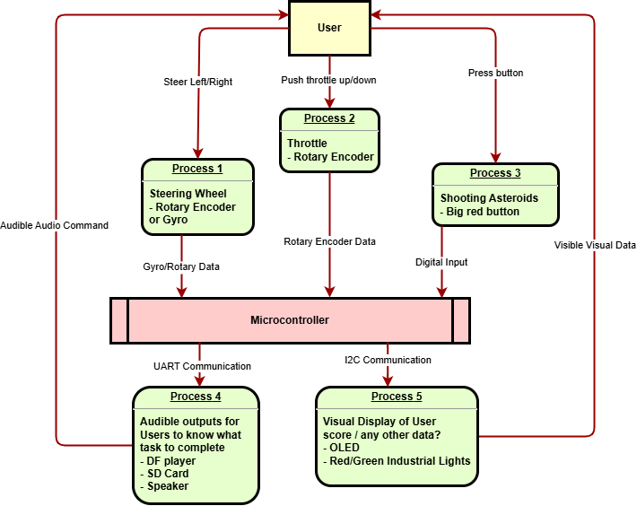

**Pseudo-Code:**

const TurnLeft=0

const TurnRight=1

const ThrottleUp=2

const ShootAsteroid=3

main():

sounds = loadSoundsFromRom()[Turn Left, Turn Right, Throttle Up,

Shoot Asteroid, Crashing, Accelerating, "Pew Pew", "Ding", "Nice Job"]

score = 0

running = false

waitTime = 10

while(!running)

running = getStartButton()

outputToDisplay(0)

while(running)

command = giveRandomCommand()

input = -1

float throttleAngle = getThrottleAngle()

float steeringAngle = getSteeringAngle()

bool buttonPressed = getButtonPressed()

if(steeringAngle > 45)

input = TurnRight

if(steeringAngle < -45)

input = TurnLeft

if(throttleAngle > 25)

input = ThrottleUp

outputToSpeaker(sounds[5])

if(buttonPressed):

input = ShootAsteroid

outputToSpeaker(sounds[6])

if (command==input):

youDidIt(score)

lightUpLEDFor1Secs(GREENLED)

else():

fail()

wait(waitTime)

waitTime/=1.1

if(score>99):

success()

return 1

def giveRandomCommand():

return randint(0,4)

def youDidIt(&Score):

outputToSpeaker(Ding)

Score++

outputToDisplay(Score)

def fail():

outputToSpeaker(Crashing)

lightUpLEDFor1Secs(REDLED)

wait(1)

running = false

def success():

outputToSpeaker("Nice Job")

wait(1)

running = false



**Preliminary Sketch:**



**Team Roles:**

Joshua Krymgold: Software Lead  
Aragya Goyal: CAD Lead  
PJ Granieri: Hardware Lead

**ECE 1895 - Enclosure Design**

**Intro:**

For our Bop-It enclosure, we have elected to use Onshape to CAD our design. We have decided to use a lot of off the shelf parts in order to make assembly quick and easy. Additionally to decrease turnaround time, we have decided to use the makerspace laser cutters to manufacture our enclosure. This has meant that the enclosure stays as simple as possible while also being easy to put together and iterate on.

**Enclosure Image:**

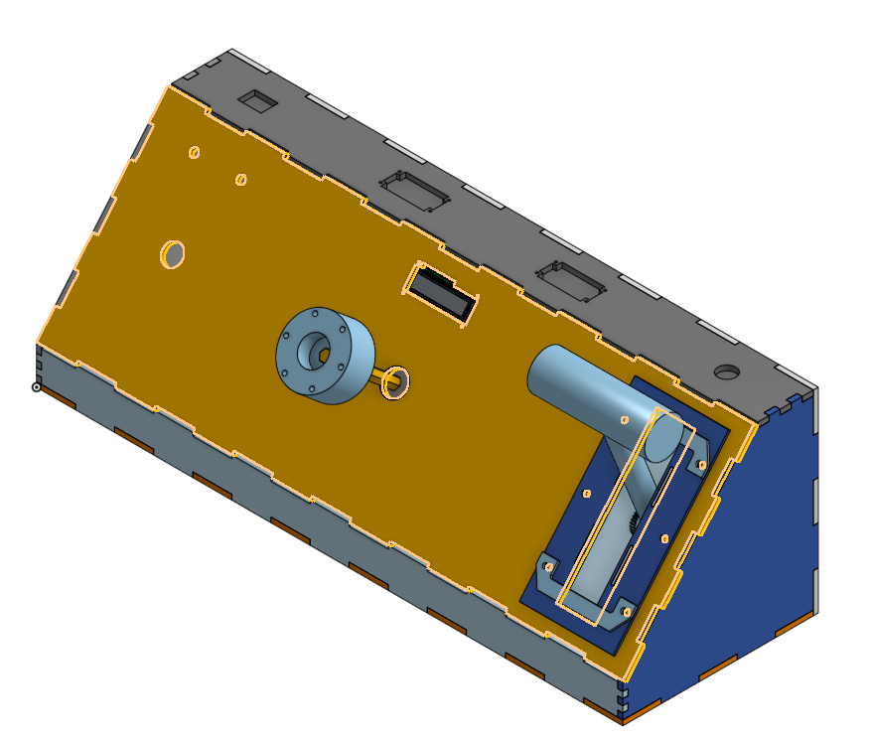

**Link to Onshape document with all design files:**

<https://cad.onshape.com/documents/046c17bd43b664fd42e98fcc/w/d44ac859b5a11a90c770b06d/e/23341a966fad6f80a06ce821?renderMode=0&uiState=67d9d67e873aee3c5bb964c6>

We also started to manufacture some of our files to see how they all fit together.

**Initial Prototype:**

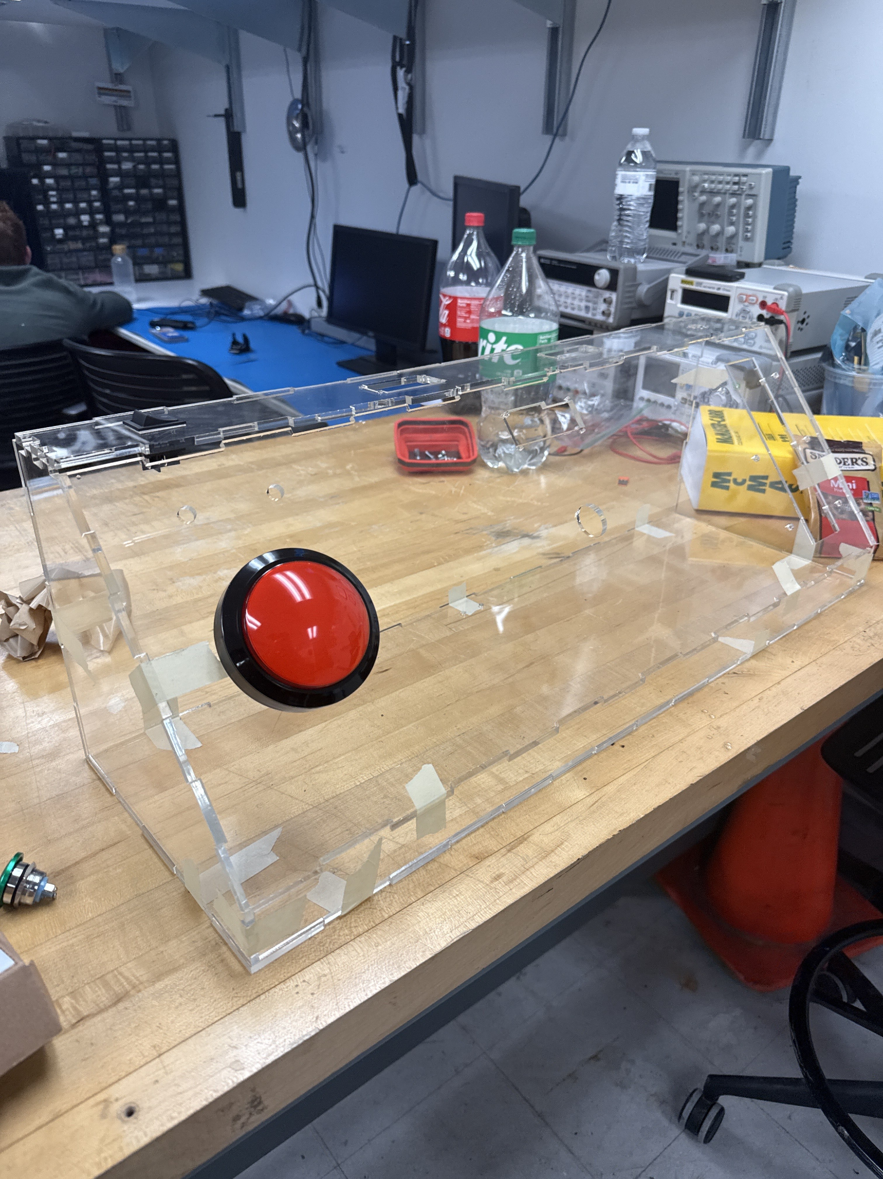

**ECE 1895 - Space Invaders Bop It Final Report**

**Design Overview:**

The Space Invaders Bop-It is an interactive game system which is designed to combine two commonly beloved games, "Bop-It", a reflex game, with a space-themed twist inspired by "Space Invaders". This game challenges players to quickly respond to randomized audio commands with three unique physical inputs: a steering wheel, a throttle, and a firing button. The goal of this game is to complete the maximum amount of tasks correctly before the allocated time runs out to succeed. If a user can successfully reach a score of 99, then they win the game.

The core concepts behind the game originate from "Bop-It", in which the gameplay mechanics feature three unique physical inputs, as well as the idea behind Space Invaders, which involved navigating a spaceship and shooting down aliens. We had several initial design ideas that were considered, such as using a gyroscope for the wheel that were set aside for simpler yet more robust analog input devices to improve reliability and minimize the complexity. Our final design uses a multi-turn potentiometer for the steering wheel, a single-turn potentiometer for the throttle, and a gigantic red push button for firing.

The game's logic randomly generates four commands being "Turn Right", "Turn Left", "Throttle Up", and "Fire". Each of these commands is delivered via audio output using a DFPlayer which is connected to two speakers. The user is expected to react within an appropriate time, which will decrease as the score increases, which creates a fast-paced gameplay experience. A correct input will increment the score, flash a green LED, and play a "ding" sound to signify the correct input. An incorrect input would trigger a red LED and then an 8 bit audio with a somber sound.

The interactive feedback system includes:

* Visual feedback via an LCD screen that displays the current score.
* Audio feedback via sound effects for each command and outcome.
* LED indicators for success (green) and failure (red).

This project emphasizes a balanced integration of electronic interaction, audio/visual feedback, and embedded systems programming, all wrapped in a space-themed, child-friendly console.

**Design Verification:**

To test our design, we had to consider the enclosure, software, and hardware being used for our system. We started out with a breadboard prototype for our software, and we used an arduino uno to help simulate the pin connections.

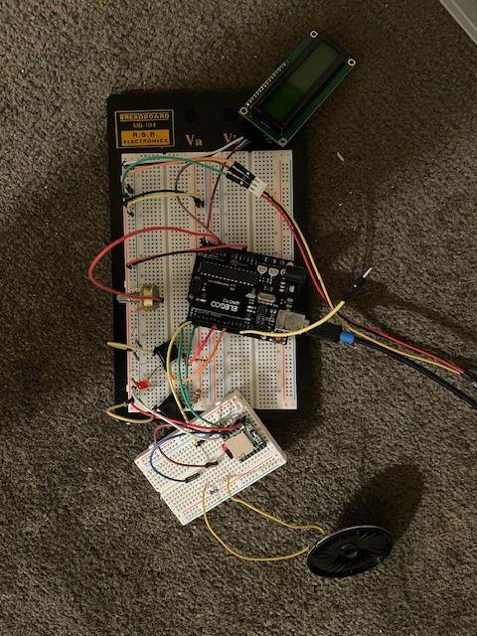

This also helped us simulate the electronics that would be used, and ensure the proper behavior would occur for both the components and the software. This breadboard prototype ultimately helped us test our software, electronics, and hardware pinouts. The only major issue we had while testing our software was the software serial. This would interfere with the timing of the arduino, which specifically became a problem when in addition to the heavy time constraints of the i2c for the lcd display. Since they both missed their timing, both failed. Here, there were two possible solutions. The easy way was to use a different software serial library. Alternate software serial libraries include the NeoSWSerial library or the AltSoftSerial library. The hard way is to use the serial ports that the arduino uses to communicate with the computer. Obviously, we chose the hard way. This means that if the serial is currently occupied by the DFplayer, then every time that we want to upload new code to the arduino, we have to ground the serial ports to prevent the DFplayer from interfering.

**Electronic Design Implementation:**

To realize our design, we selected components that would provide reliability, durability, and ease of integration with the ATMega328P. Our input system consists of three devices: a multi-turn potentiometer for steering input, a single-turn potentiometer for the throttle input, and a push button for firing input. These components were chosen for their analog signal output, which simplifies input detection using standard ADC pins on our ATMega.

Initially, we considered using a gyroscope to detect steering input, but for simplicity purposes we opted to use a potentiometer for ease of usage and reliability purposes. During our initial enclosure testing, we experimented with a configuration that ultimately damaged the potentiometer for the steering wheel by excessive rotation. This prompted us to upgrade to a multi-turn potentiometer, which ensured an improvement in durability for repeated usage. This ironically was not reliable however, as there was drift in the potentiometers value, which caused an incorrect input. We ultimately solved this problem via a software fix.

For audio feedback, we used a DF Player which is connected to two speakers. This component was selected due to ease of use and the ability to store and play multiple sound files from a microSD card. It interfaces with the ATMega via UART. We also used decoupling capacitors to minimize the DFPlayer interference with any other signals.

For visual outputs, we used an LCD to display the user's score. The LCD interfaces via I2C which was helpful for minimizing pin usage. The LCD provides clear visual feedback of the players score, while the two LEDs are used to display to the user if their input was correct or not. The green LED symbolizes a successful input, while a red LED symbolizes an unsuccessful input.

All of these components are integrated with the ATMega328p which has a regulated 5V source from a 9V battery to power everything. This also ensured compatibility with all of the electronics that we have used within our design.

One problem that we ran into with the PCB design is that the AVCC pin of the ATMega328p was not hooked up to a 5V trace, and was instead left as an open circuit. This caused a problem where our potentiometers were reading incorrectly on the arduino because they had no reference voltage.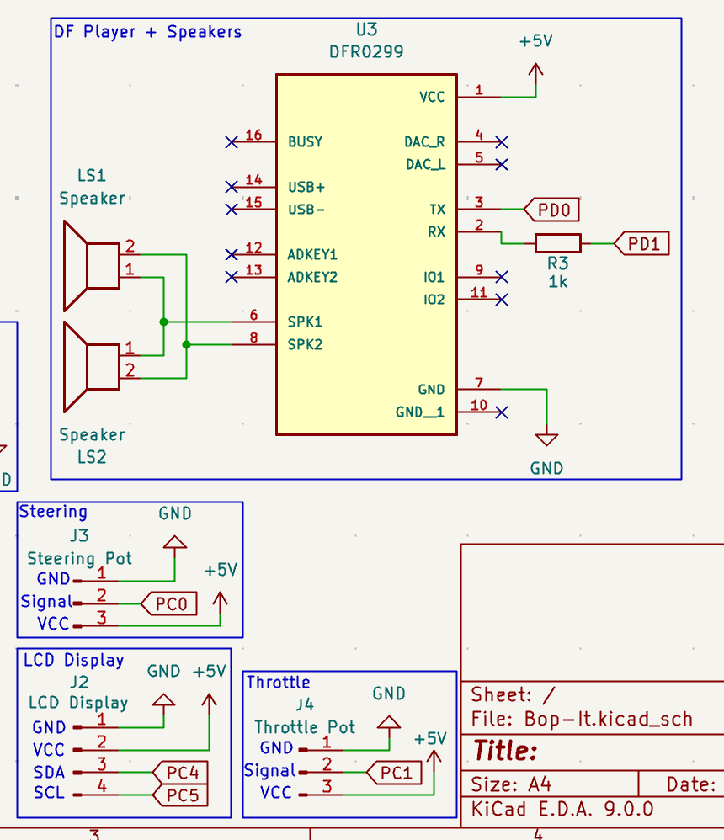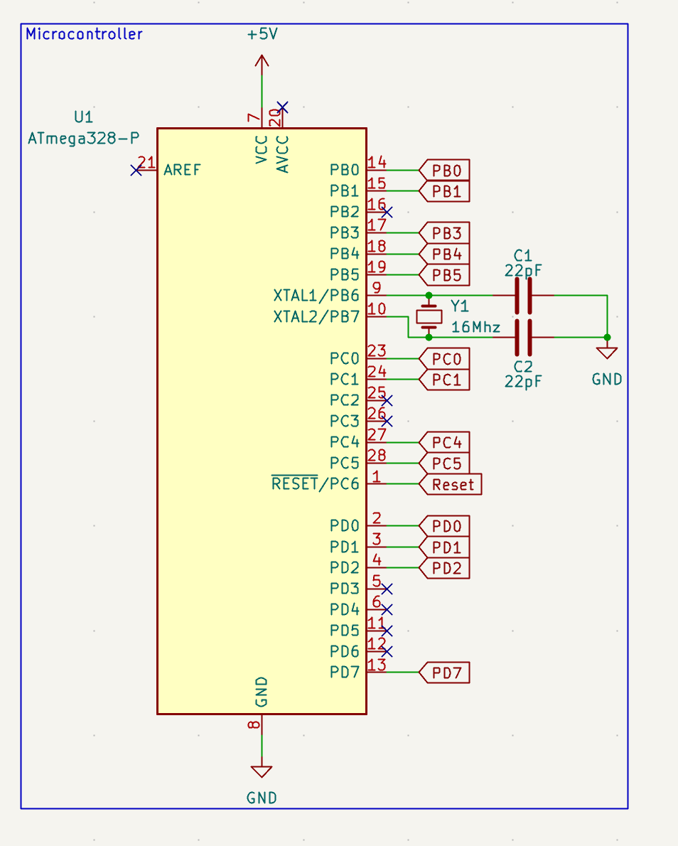

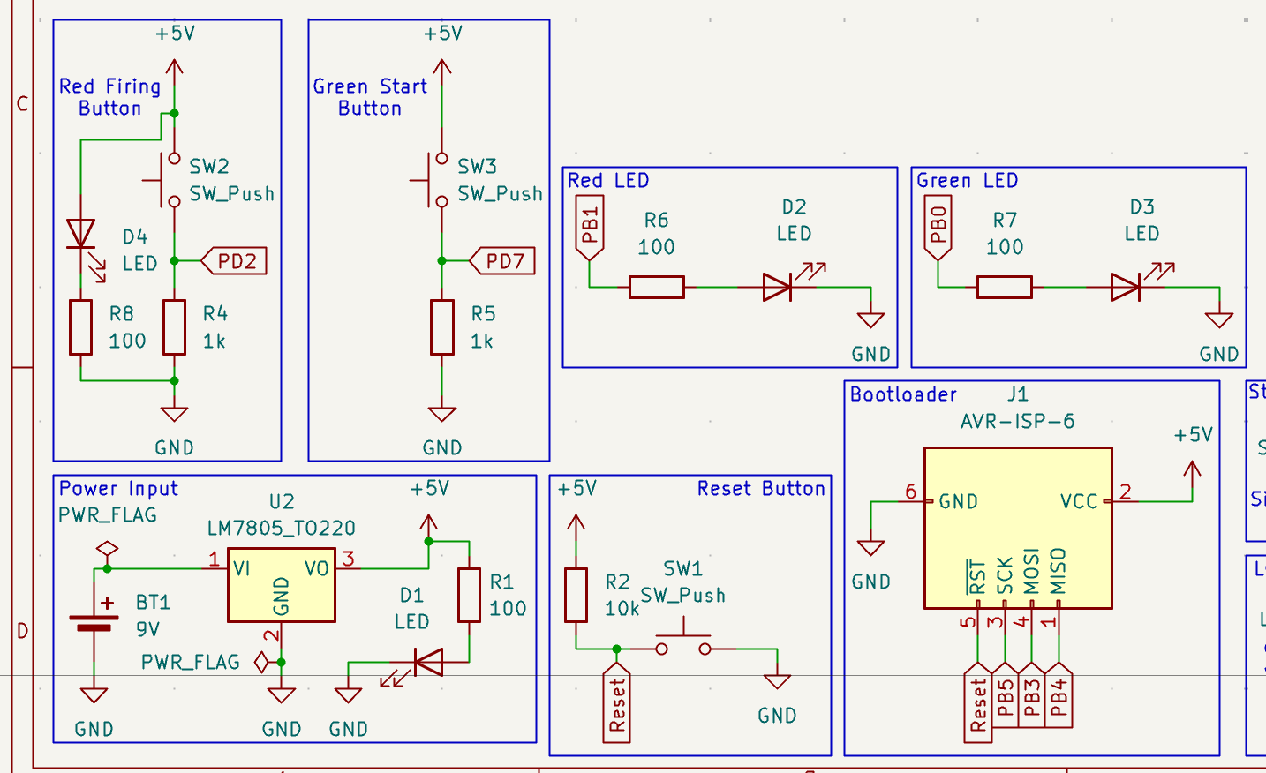

**Software Implementation:**

The program can be viewed as a very big finite state machine. Upon powering on the computer, the initial state of the program is the “wait for start” state. Here it just repeatedly reads a digital input for whether or not the start button is pressed. Upon the start button being pressed, it moves on to the “initialization” state of the program. Here, the timer is set, the first command is given, the failure light is set to low, the lcd is set to 0, and the score is reset. After this, there is the “wait for inputs” stage. Here we check for if any of the inputs have been activated.

* The fire input is activated when the fire button is pressed
* The throttle input is activated when the voltage received by the arduino from the throttle is >78.125% of AVCC(analog voltage)
* The wheel input is activated when the voltage received by the arduino from the wheel is no longer within 2.441% of the initial percentage of AVCC received, whether that be greater or less than. This is much smaller than the above, due to the 10-turn potentiometer.

If the time limit is reached, then we move to the “failure” stage, otherwise, if the user presses an input within the time limit, we move to the “check input” state. In the “check input” state, it checks if the input is correct, if it is correct, we then move onto the “play input sound” state, otherwise, we move to the “failure state”. In the “failure state”, a losing sound is played, as well as a red light is lit. It moves to the “wait for start” state. In the “play input sound” state, if there is a sound for an input (there are sounds for throttle and fire inputs), then it is played. In addition to this, we decrease the amount of time that the user has to enter an input*, as well as update the lcd display to the new correct score. After 2 seconds, we move on to the “play ding” state, where we play a ding sound, as well as light the green led. After 2 seconds if the score is greater than 99 we move to the “you win” state, where the you win sound is played, and we move back to the “wait for start” state. Otherwise, after 2 seconds we move onto the “get next command” state, where the program randomly chooses the next command and then plays the sound corresponding to that sound, as well as sets the green led to low and resets the start time of the timer. After this state, we move back to the “wait for inputs” state.

We would like to note that while the program operates like it does above, we did not program it with the intention of it being a finite state machine, we only realized that it was one after. Therefore, the states and actions corresponding to those states, are connected together with if statements and booleans.

All of the above code operates in the loop part of the arduino code. The setup part of the code simply initializes all of my outputs and inputs, making sure that they are ready to read. The only one that is different from normal is the 10-turn potentiometer, which we get the initial value of, due to a problem that we encountered where this potentiometer seems to have adjusted the value resistance value at the initial position, without the potentiometer having moved.



*The equation for modifying the time is $10000(3)^{0.965x}+10000$, where x is an integer corresponding to the number of turns that have passed.

We used the DFRobotDFPlayerMini, LiquidCrystal_I2C libraries in our code.

**Enclosure Design:**

The enclosure was designed in Onshape. Designed as a futuristic console, the enclosure is made of ¼ in acrylic with a separate small enclosure for the throttle. We use a combination of 3D printed materials and COTS components. This helped us to balance between build time and made integration easier. The main things that the user can interact with are a power switch, a green start button, a big red button, a steering wheel, and a custom throttle.

The main challenge when designing the enclosure was making it so that the steering wheel would feel natural and semi robust. To design the general steering column, we designed a 3D printed piece that would sit at the back of the box and would hold a bearing to make sure that the steering is well supported. We also decided to put the encoder for the steering on that 3d printed piece as it would be easy to attach. On the steering column, we also 3D printed a piece to hook bungee cords up to. This allows for the steering wheel to return to the center making it easy for the user to not have to worry about recentering the wheel every single time they use it.

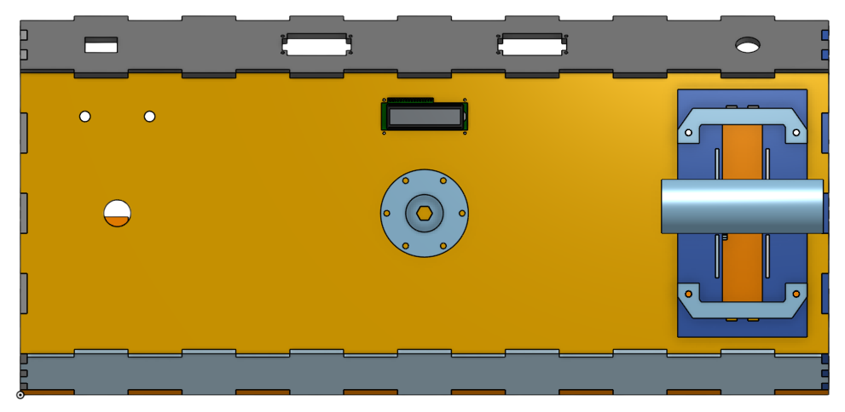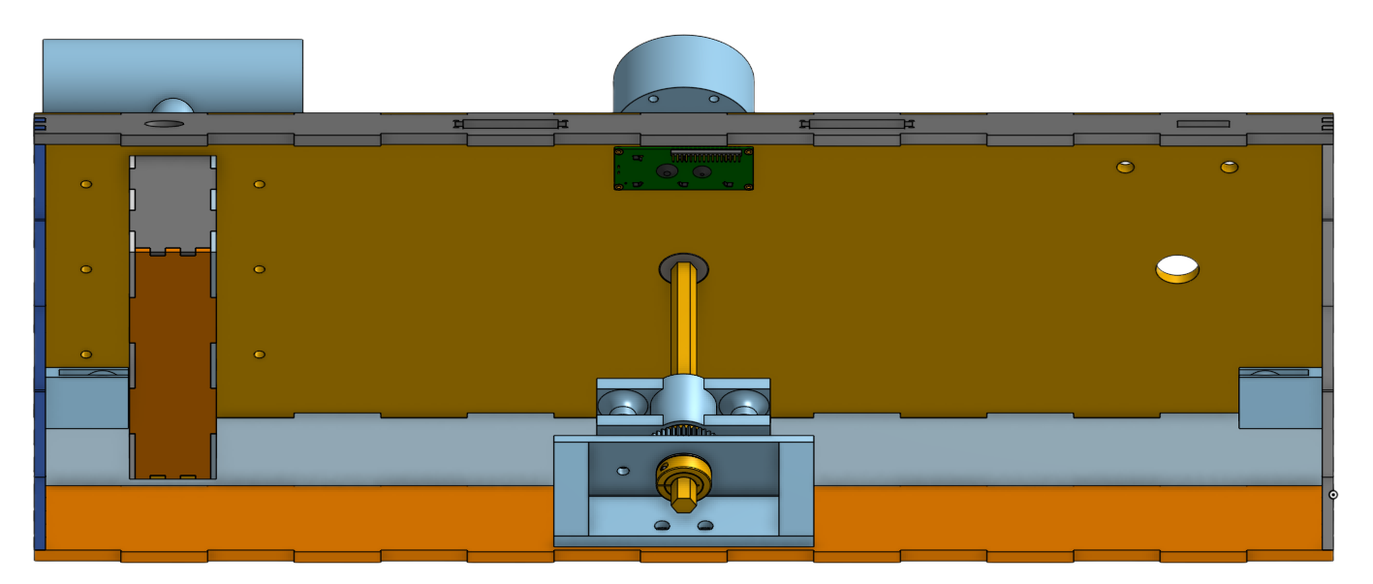

**Assembly and System Integration:**

For assembly, our team first started by putting together the enclosure and the electronics inside of the enclosure. We then started to wire up the PCB according to our PCB schematic. At this point, we tried testing the whole system and discovered that we were getting nonsensical outputs from the system where we would be told that our input was correct even when doing nothing. We spent a big chunk of our time trying to debug this one issue and upon review of the PCB schematic we discovered that the AVCC pin on the ATMega chip was not connected to anything. We deduced that due to the fact that the outputs were correct and constant low and constant high voltages, there must be a problem with the voltage that the arduino was receiving. After some discovery online, we found that this pin must be connected up to VCC in order to get correct readings off of the internal ADC. Once we had learned about this, we used a jumper cable to connect the AVCC pin up to VCC which fixed the nonsensical readings. After this point, we fully enclosed the enclosure and were able to test play it until score 100.

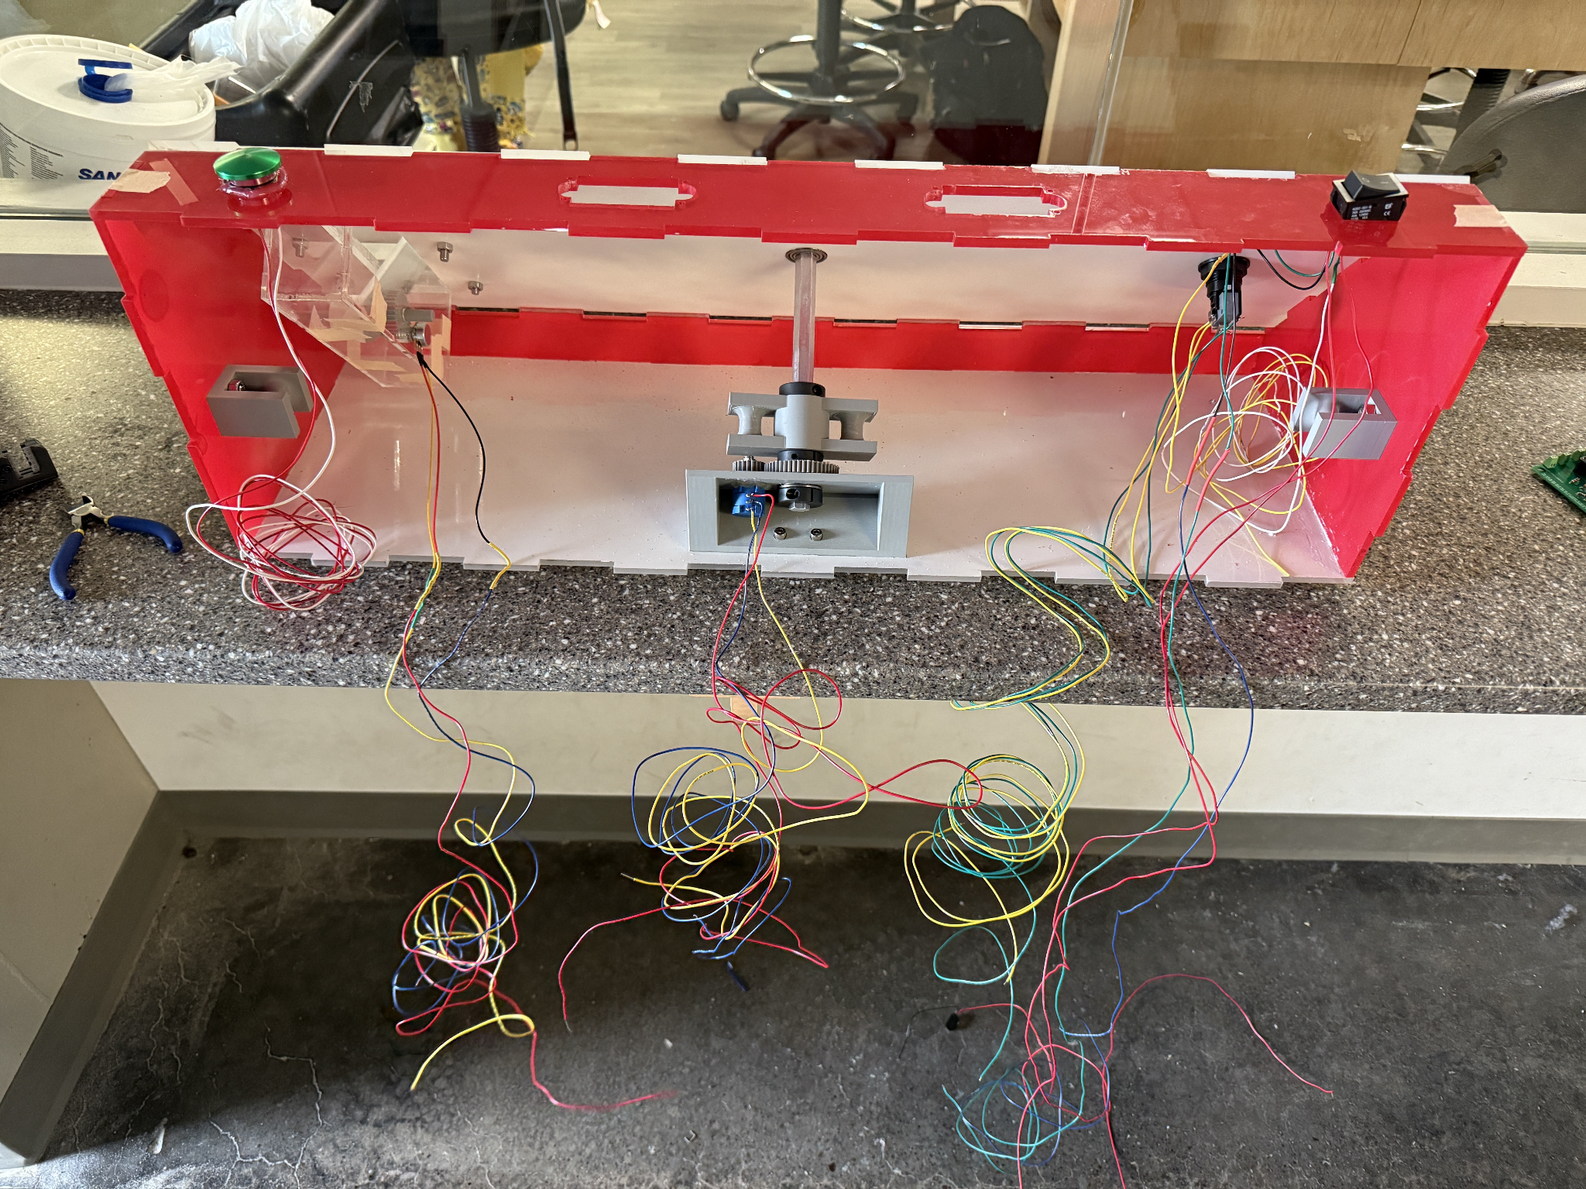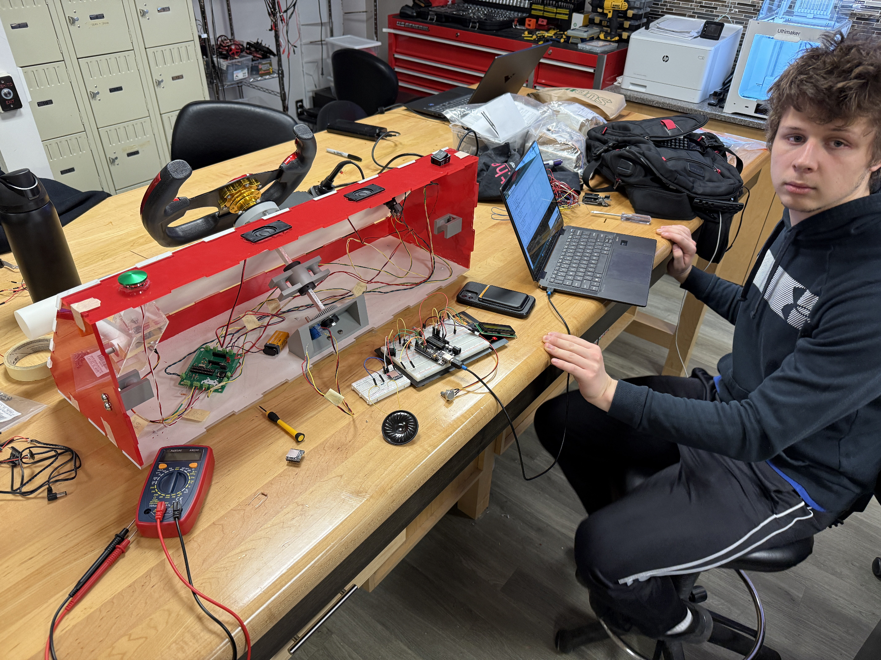

**Design Testing:**

After our in class demonstration, we had figured out that our potentiometer being used for the steering wheel input drifted and resulted in constant incorrect inputs from said potentiometer. This ultimately caused the game to become unplayable and demonstrate improper behavior. To mitigate this, we had to reload the ATMega with new software which accounted for the default position when the device was turned on.

**Budget and Cost Analysis:**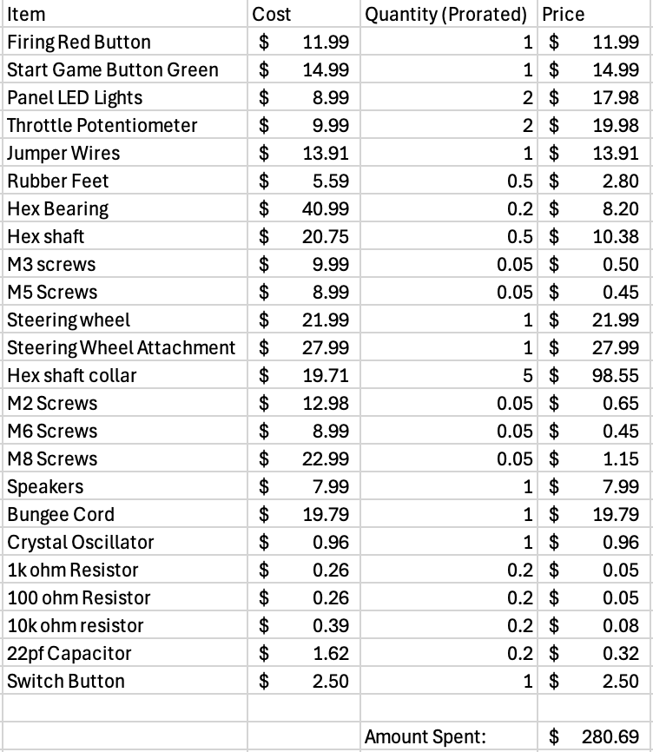

​​For our budget we exceeded 250+ dollars for a single unit. With the electronic and mechanical components costing $280.69. For our PCB, we could estimate a price of $4 dollars and $22 for shipping. Overall, accounting for 10,000 copies, the total amount would be $2,846,900 dollars before shipping included.

**Team:**

We had three members on our team. Primary method of communication was through texting and a discord group chat. We split group roles into enclosure design, PCB design, and software design. All members were involved in integration of the whole system. Listed are the different responsibilities each person had:

Aragya Goyal: Enclosure Design

PJ Granieri: PCB Design

Joshua Krymgold: Software Design

**Timeline:**

There wasn’t a true schedule to this project, but there were some important dates involved:February 20th: Initial Proposal

April 3rd: PCBs arrive  
April 14th: Project Demo

When we first arrived back from spring break, we focused on designing a breadboard prototype that was functional. Once this was confirmed, we ordered our PCBs around March 23rd-24th. We focused on our enclosure in the background as well, and had a fully assembled exterior for the enclosure. We then focused our efforts on the mechanical parts for the enclosure while waiting for our PCB to arrive. Once our PCB arrived, we soldered everything together and wired it up to life. Due to integration it wasn’t perfect the first time around, so we had to make some modifications to get it to work. Ultimately, we finished on April 12th with a functional game.

**Summary, Conclusions, and Future Work:**

The Space Invaders Bop-It is a fun, fast-paced game that successfully blends the reflex-based mechanics of Bop-It with the classic space combat feel of Space Invaders. By combining intuitive physical controls, responsive audio-visual feedback, and well-structured game logic, we created an engaging and interactive experience.

Along the way, we faced a few challenges—like analog drift, serial communication conflicts, and power delivery issues—but through testing and iteration, we found practical solutions.

If given more time, we believe it would be a cool addition to add an OLED display and have our game actually connect to a space invaders game so that you could actually play the game by the inputs that you send into the game. We would also like to work on improving the stability of the enclosure potentially looking into the use of wood instead of acrylic for the enclosure. In the end, we built a game that’s not only functional but also fun to play. With some further improvements, it could be made more structurally robust and more interactive for the user.